Name: Ajay Kumar Reddy
Reg No: 192425274
Create an empty plot with specified axis limits using Python.

Aim
To create an empty plot and set specific limits for the X-axis and Y-axis using Python's matplotlib library.

Code
import matplotlib.pyplot as plt
# Create empty plot
plt.figure()
# Set axis limits
plt.xlim(0, 10)
plt.ylim(0, 20)
# Labels and title
plt.xlabel("X Axis")
plt.ylabel("Y Axis")
plt.title("Empty Plot with Axis Limits")
plt.show()
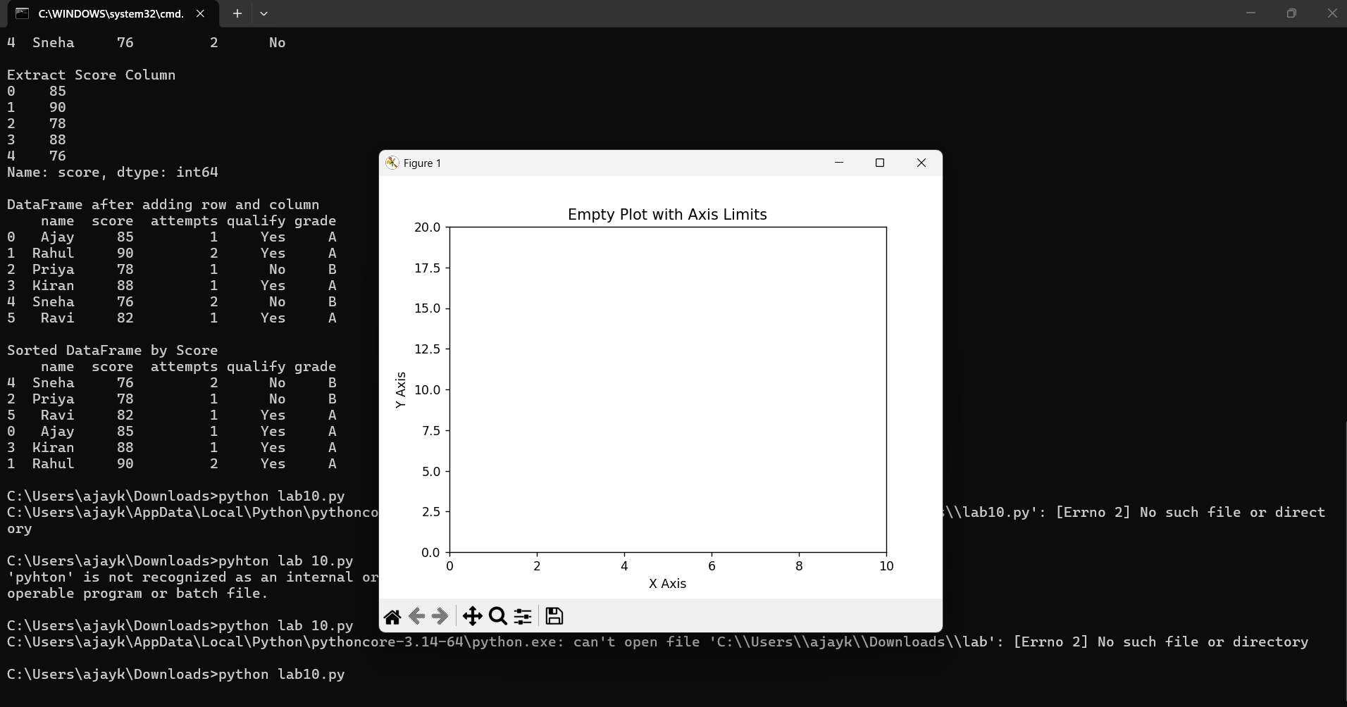

Output
An empty graph window is displayed with X-axis range from 0 to 10 and Y-axis range from 0 to 20. Take a screenshot of the generated graph after running the program.

